**EXP NO 4: CREATE A SIMPLE CLOUD SOFTWARE APPLICATION FOR CAR BOOKING RESERVATION SYSTEM USING ANY CLOUD SERVICE PROVIDER TO DEMONSTRATE SAAS.**

**DATE:**

**AIM:**

To Create a simple cloud software application for Car Booking Reservation System using any Cloud Service Provider to demonstrate SaaS.

**PROCEDURE:  
 step1:** Go to zoho.com.  
 **step 2:** Log into the zoho.com.   
**step 3:** Select one application step.

**step4:** Enter application name as Car Booking Reservation System.   
**step 5:** Created new application as Car Booking Reservation System.

**step 6:** Select one form  
 **step 7:** The software has been created.

**IMPLEMENTATION:**

**STEP1: GOTO ZOHO.COM**

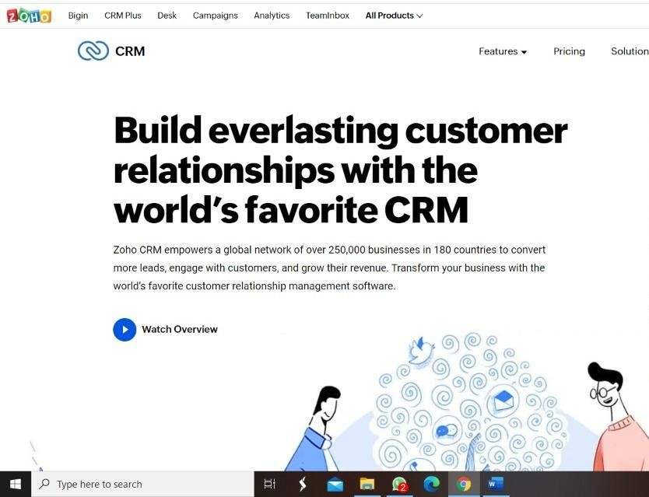

**STEP 2: LOGINTOTHE ZOHO.COM**



**STEP 3: SELECT ONE APPLICATION**

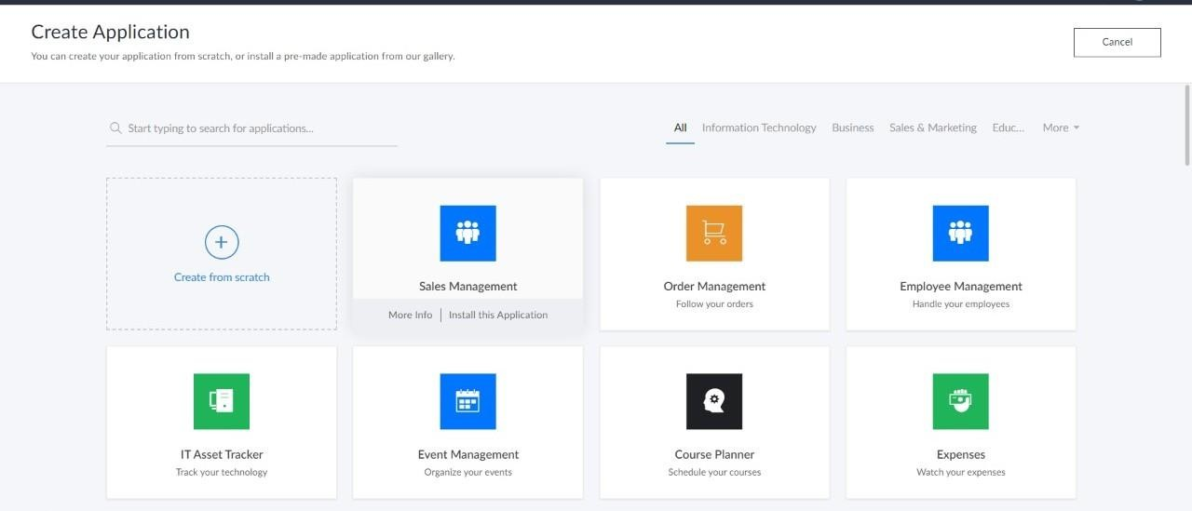

**STEP 4: ENTER APPLICATION NAME**

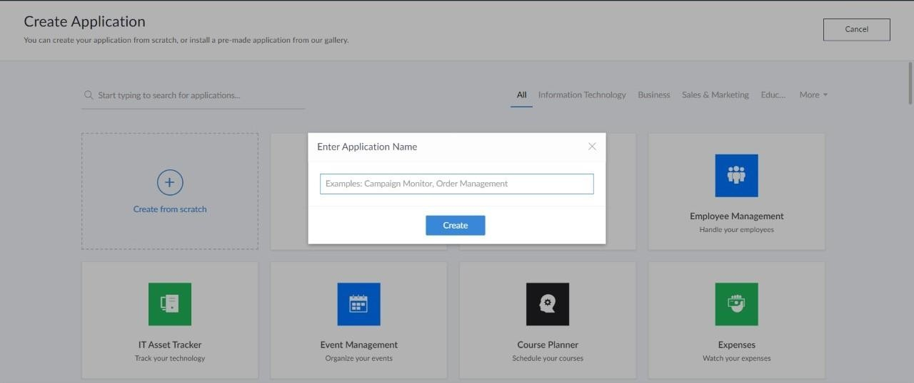

**STEP 5: CREATED NEW APPLICATION**

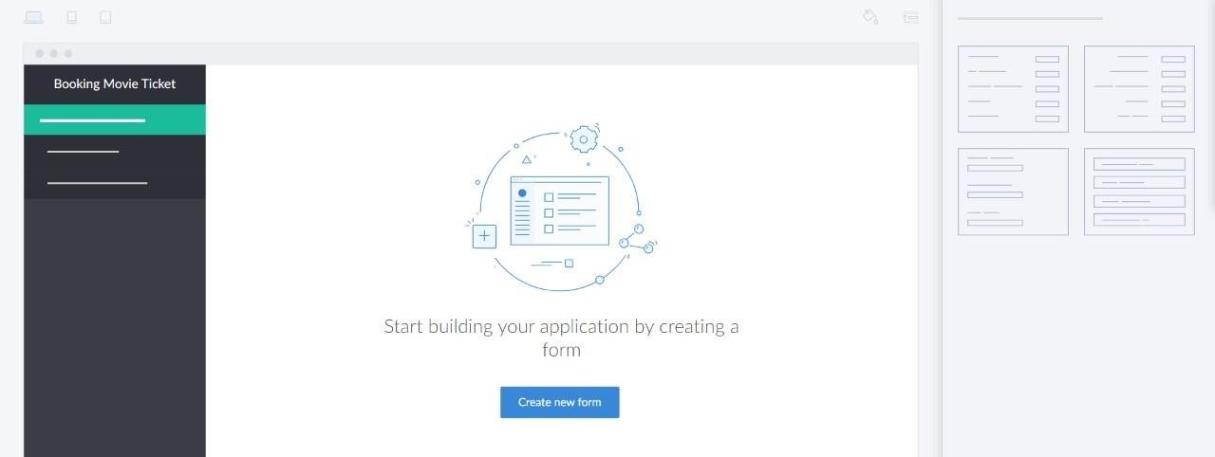

**STEP 6: SELECT ONE FORM**

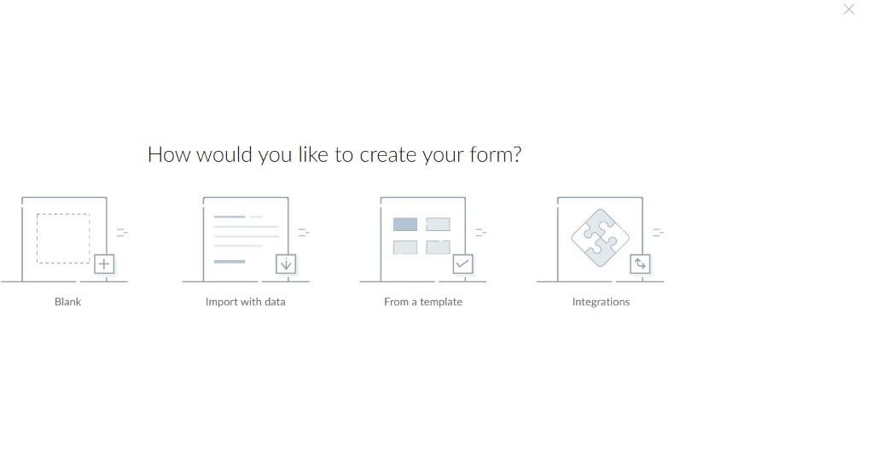

**STEP 7: THE SOFTWARE HASE BEEN CREATED.**

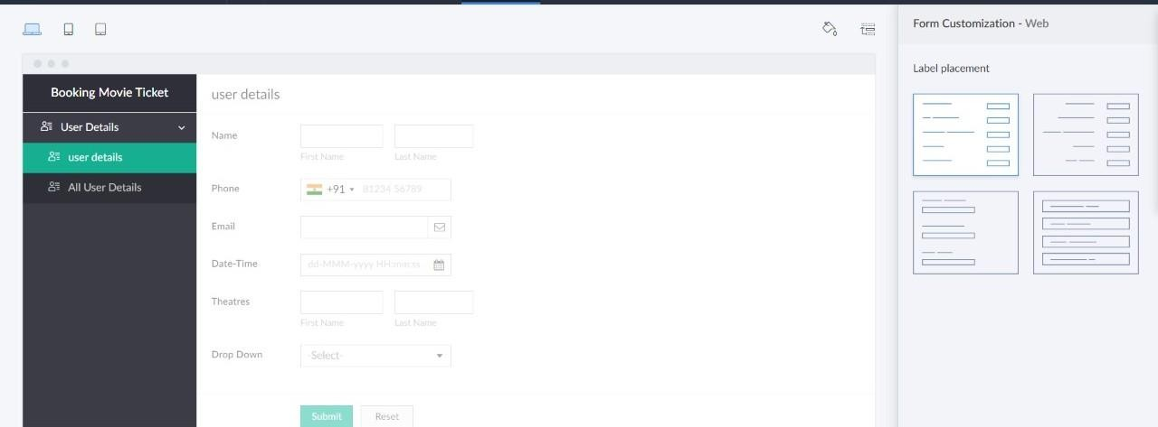

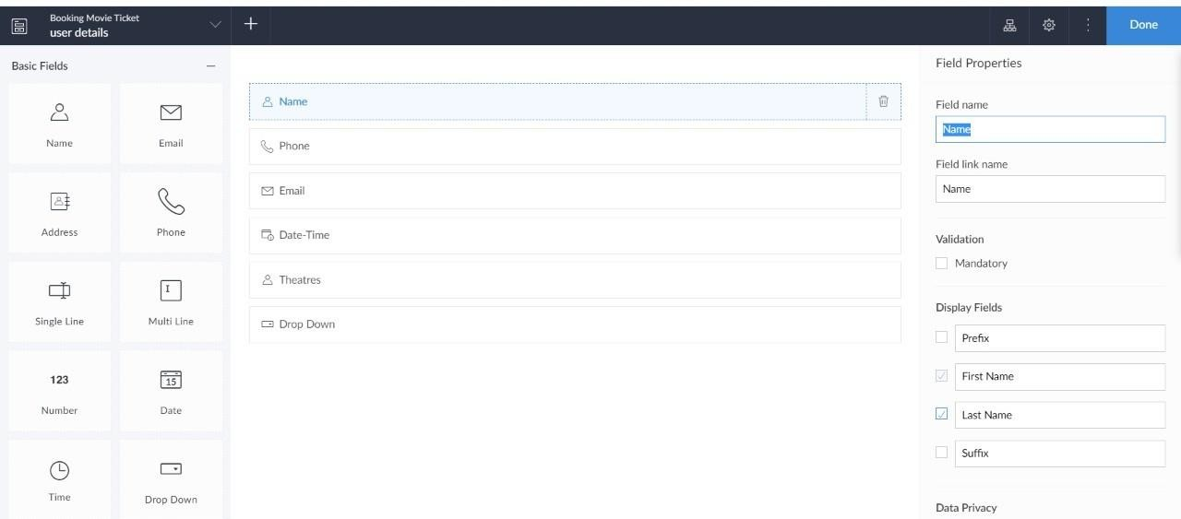

Sample output:

Passenger Details:

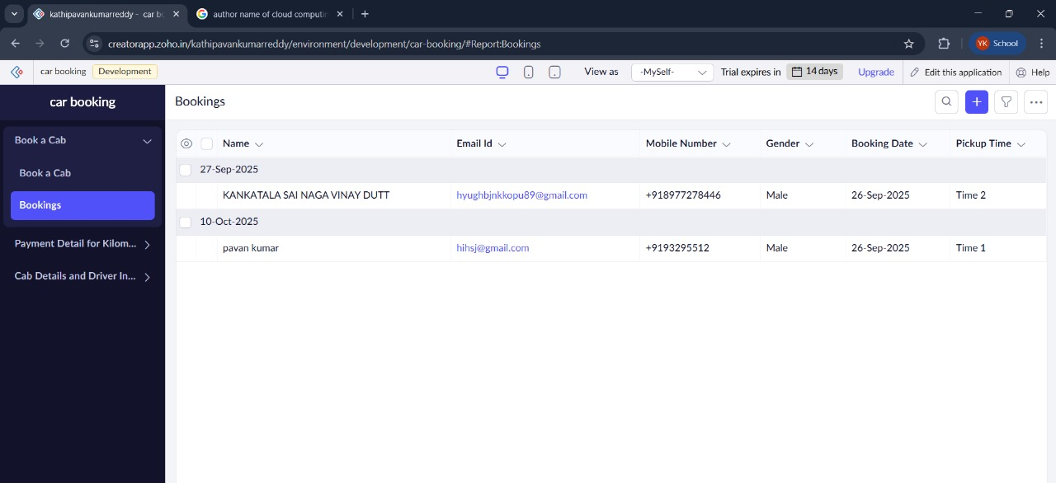

Driver and Cab details:

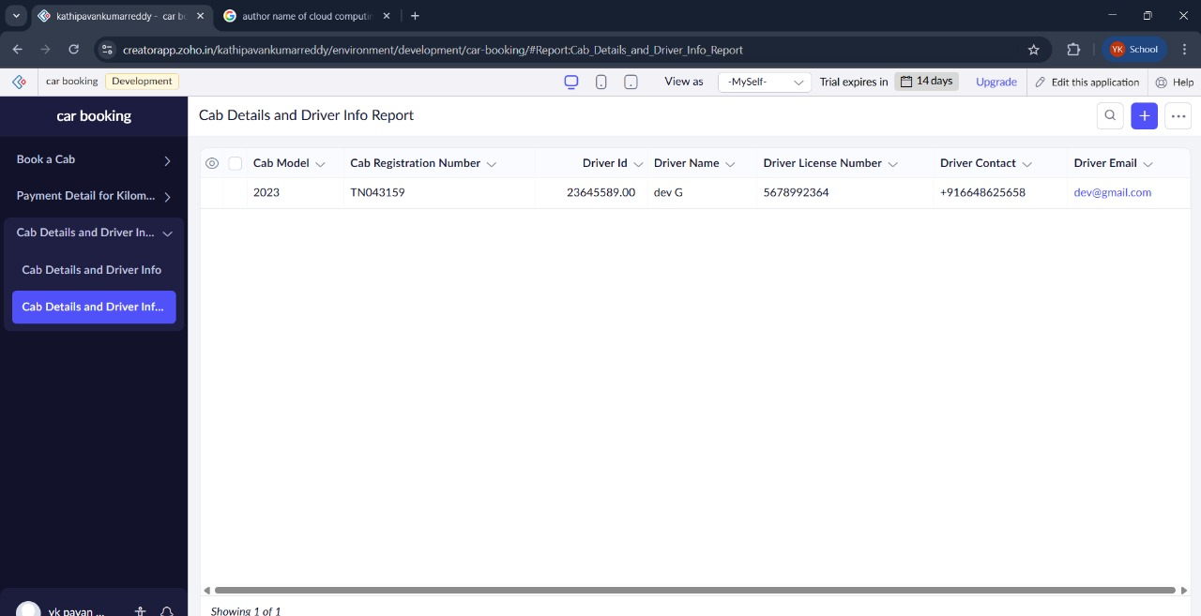

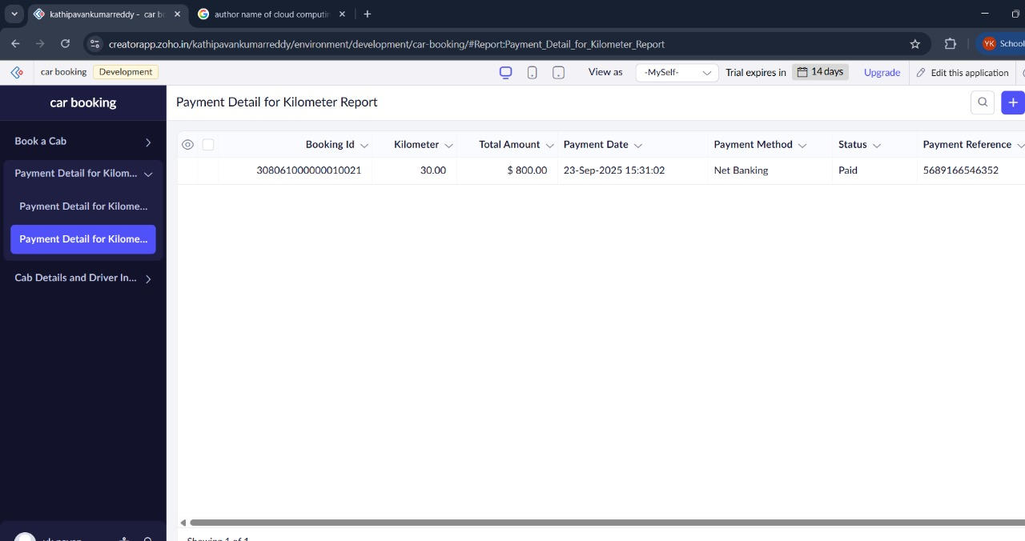Payment Details: